Course Code: ANL551 Data Analytics for Decision Makers

Title: Group-based Assignment January 2023

Team B

PI No.:

K2311118

Name:

Ng Peng Chong, Lester

Submission Date: 21 Feb 2023

1. Business Understanding

In the move towards a cashless society, the use of credit card has become more and more prevalent. In Singapore, 90 per cent of respondents have used a debit or credit card in the last three months, the highest debit and credit card penetration rate in ASEAN1. For a credit card provider, the main sources of income comes from interest from credit card accounts and fees collected from merchants2. In short, credit card providers make money through customer’s use of the credit cards. As such, customers’ attrition can affect the income for credit card providers.

In this report, we will explore if there are factors that can be identified for customers who are more likely to cancel the credit card and if there are changes in customers’ behaviour that can better predict the likelihood of a customer cancelling the credit card in the future.

1. Data Understanding

We will be using a dataset containing customer information from an anonymous credit card provider obtained from Kaggle3. It contains demographic details of customers such as age, gender, education, martial status and income as well as customers’ history with the credit card provider and spending behaviour.

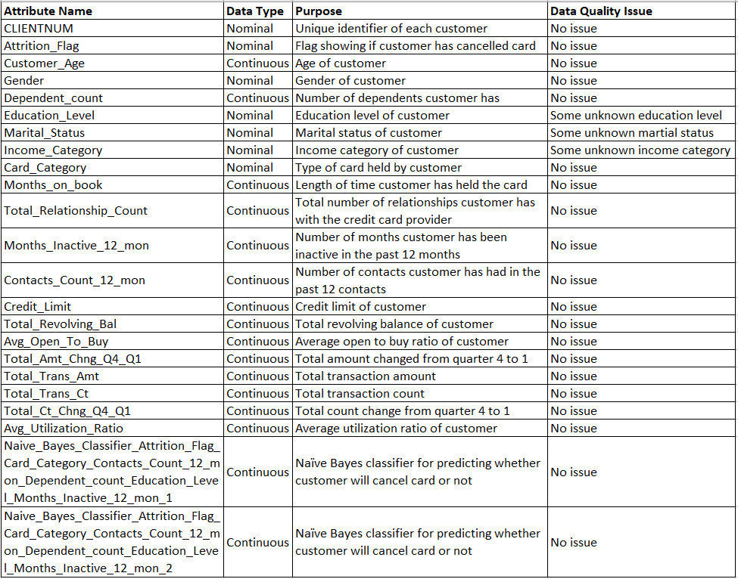

Below is a sample of the dataset to be used.

1. Data Preparation
2. Modelling
3. Evaluation
4. Deployment

References

1 FinTech in ASEAN 2021 research question A1: Thinking about your shopping habits, which of the following payment methods have you used in the past 3 months (both in-store and online)? Base: Total respondents.

2 <https://www.valuepenguin.com/how-do-credit-card-companies-make-money>. Retrieved 13 Feb 2023.

3 <https://www.kaggle.com/datasets/thedevastator/predicting-credit-card-customer-attrition-with-m>. Retrieved 12 Feb 2023.